
ESTS Course on TB and other Lung Diseases of Surgical Interest
The Course is organized jointly with WHO Collaborating Centres
20 – 23 November 2017
WHO Collaborating Centre for TB and Lung Diseases, Cepina, Italy
Registration Form

Please return this form via email to: sue@ests.org.uk

Please complete clearly in either PRINTED FORMAT or BLOCK letters:

Dr/Prof/Mr/Mrs/Miss Family Name: ………….. First Name:

Organisation:

Address:

City, Postal Code: Country:

Telephone: Mobile Tel:

Email 1: ………………………………………………… Email 2:

REGISTRATION

The registration fee includes:
- Admission to the course programme
- Four nights single room 4* hotel accommodation
- Certificate of attendance
- Two coffee breaks on 3 days
- Luncheons and dinners on 3 days
- Local transport from Tirano to Cepina
- One social activity

Fee Euro 400.00 - For ESTS Members and Non Members

HOTEL ACCOMMODATION

Accommodation for four nights is included in the registration fee from hotel check-in on Monday 20 November 2017 until check-out on Friday 24 November 2017 at Hotel Cepina, Via Roma 120, 23030 Cepina Valdisotto (SO), Italy http://www.hotelcepina.it/en

TRAVEL INFORMATION – please see detailed instructions at the end of the registration form

Monday afternoon arrival, 20 November 2017

Please arrange your flight to Milan Malpensa/Linate to arrive to take the 14:20 train from Milan to Tirano. The train will arrive in Tirano at 16:50 where there is a group transfer by bus to the hotel at Cepina where the WHO Training Centre is situated.

Participants need kindly to organise their flights accordingly, and in case they arrive earlier, enjoy shopping or visit to Milano. In case, a Taxi service is available from Tirano train station to Hotel Cepina, Cepina.

Friday morning departure, 24 November 2017
08:00 hours departure by bus after breakfast to Tirano station. The train departs at 09:10 arriving at Milan Central Station at 11:50 hours.

PAYMENT

Payment by Bank Transfer
Account Name: European Society of Thoracic Surgeons Bank: Royal Bank of Scotland

Account No. ESTSX-EURC IBAN Code: GB 75 RBOS 1610 7010 0206 45
SWIFT/BIC Code: RBOS GB 2L Bank sort code: 16-10-70
Payment must be made in full and bank charges will not be paid by ESTS and are to be paid by the participant. We do not accept cheques.
Payment by Credit Card (Signature of card holder required)  Visa  Mastercard

Card number: Expiry date:

Cardholder's name:

Signature:

CANCELLATION POLICY/TERMS AND AGREEMENT
Registrations must be received by ESTS by Wednesday 1 November 2017. Registration can only be confirmed once payment is received. 50% of the registration fee will be reimbursed up to 14 days before the course. No refund will be granted after that date. A change in VAT may lead to different prices.
ESTS cannot be held responsible for any loss or damaged incurred

Please indicate by signing that you agree to the above terms (Name) ……………………………………….
TRAVEL INSTRUCTIONS AND PRACTICAL INFORMATION
Your Itinerary
- Milan airport (Malpensa/Linate) → Milan Central Railway Station
- Milan Central Station → train to Tirano
- Tirano → Cepina (Hotel Cepina) – bus transfer or public bus or taxi

Travel details

- Milan Malpensa Airport – Milan Central Station: (by Shuttle bus: direct trip)
For prices and further info visit website: http://www.malpensashuttle.it/en/index.html
10,00 € :one way ticket Malpensa Airport - Milano Central Station
16.00 € : round trip ticket
FREE WIFI ONBORD SERVICE
Milan Linate airport– Milan Central Station: a shuttle bus service is available there to Milan Central Station every 30 m’, ticket on board)

2) Milan Central Station – Tirano: (by train) : cost of train ticket (one way): 11,50 euros
3) Tirano – Cepina: (by bus transfer): only for people taking the train in Milan at 2:20 p.m
(by taxi) (one way cost: 50 euros approximately)
(by local bus): only for people taking the train in Milan at 4:20 /6:20/7:20 p.m

Please note

1. The air travel should be booked to Milan Malpensa/Linate Airport (not Rome)
2. If unfortunately your luggage will not reach Milan Malpensa/Linate airport, please contact the Lost and Found Office at the airport, giving the following address where to send your luggage:
HOTEL CEPINA
Address: Via Roma, 120 , 23030 CEPINA Valdisotto (SO) Italy
Tel: +39 0342 951161 Fax +39 0342 950583
Including also the following reference mobile phone number: +39 338 8639523

Train and Transfer Information

In Milan Central Station take a train direction: Colico-Sondrio-Tirano
Tirano train station is the last train stop (see train timetable)
ATTENTION: AT MILAN CENTRAL STATION BUY THE TRAIN TICKET TO TIRANO (AND NOT TO TORINO).

With red arrow the suggested train option (in connection with the bus transfer in Tirano)

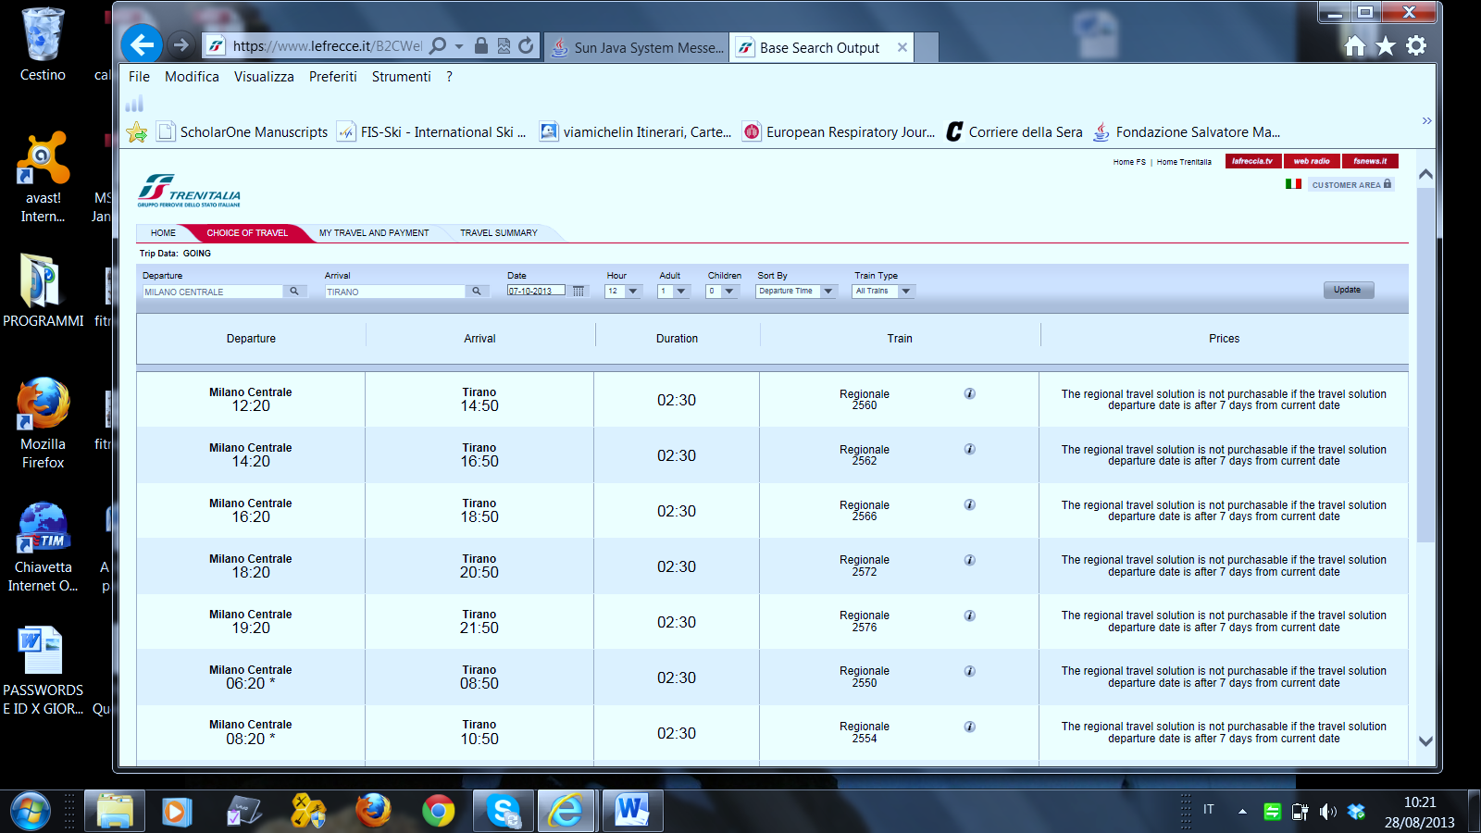

1) A bus transfer at Tirano train station for Cepina will be organized on Monday November 20 (at 5:00 p.m) for participants who will be taking the train in Milan Central Station at 2:20 p.m.
No other bus transfer will be provided by the organizers for participants who will be arriving to Tirano station at 2:50p.m / 6:50p.m / 8:50p.m/ 9:51p.m.
Normally the last train from Milan Central Station to Tirano train station is scheduled at 7:20p.m

*A taxi service outside Tirano train Station is always available (give the address mentioned above).
Taxi phone numbers: +39 349 5344935/ +39 339 3951999 +39 +39 0342 702663

2) A bus transfer from the Hotel Cepina to Tirano train station will be also organized on Friday November 24 (at 8:00 a.m) for the train leaving from Tirano at 9:10 a.m (arriving to Milan Central Station at 11:50 a.m).

HOTEL BOOKING IN MILAN (if needed)

IMPORTANT: while booking on line an hotel, according to your flight schedule, select the hotel either near Milan Central Station or near Malpensa airport ( choose an hotel near Malpensa airport whether your flight has been scheduled very early in the morning (you will be dropped off to the airport by the shuttle service of the hotel)

morningon your fligan ht schedule very early in the morning).

Here below you find a tentative list of hotels in Milan near Malpensa airport; this list is not intended to imply a WHO Collaborating Centre’s recommendation.
HOTELS NEAR MALPENSA AIRPORT

1. Hotel Tre Leoni, Viale Maspero, 10 - Somma Lombardo (Varese)
Tel: +39 0331 255520 Fax: +39 0331 252700.
Address email: info@hoteltreleoni.it Web site: www.hoteltreleoni.it§.
3 Stars hotel
It's near Malpensa airport. (Shuttle bus service included)

2. First Hotel Malpensa, Via Baracca, 34 - 21019 Case Nuove, (Varese).
Tel: +39 0331 717045 Fax: +39 0331 230827 or 230492.
Address email: booking@firsthotel.it Web site: www.firsthotel.it
4 Stars hotel
It's near Malpensa Airport.(Shuttle bus service included).
3. Hotel Cavalieri della Corona (Best Western Hotel),Via Barolo 12, 21010, Cardano al Campo (VA)
Tel:+39 0331 730350 Fax: +39 0331 730348 (Shuttle bus service to/from the airport)
Email:info@cavalieridellacorona.com

4. Osteria della Pista dal 1875

Via Verbano 1, 21011 Casorate Sempione, Casorate Sempione (VA) 7 km from Malpensa airport.
Tel: + 39 0331295054
E-mail: info@lapistahotel.it info@osteriadellapista.com
(Shuttle bus service to/from the airport)
Check-in e check-out express

HOTELS in MILAN CITY (Milan Central Station area)

Hotels 4 stars rating

Hotel Mediolanum, Via Macchi Mauro,1- 20124 Milano.
Hotel Michelangelo - Via Domenico Scarlatti 33, Milan

Starhotels Anderson - Piazza Luigi Di Savoia 20, Milan

Una Hotel Century - Via Fabio Filzi 25 B, Milan

Starhotels E.c.h.o - Viale Doria Andrea 4, Milan

Hotel Berna - Via Torriani Napo 18, Milan

Hotels 3 stars rating:

Hotel Amadeus, Via Lepetit Roberto, 27(Via Vitruvio)- 20124 Milano.
Tel: +39 02 6692141 or +39 02 66713291. 3 Stars hotel
http://www.book-a-hotel-in-milan.com/it/hotel/hotels/amadeus/
E-mail: amadeus@milanohotels.com
The eventually accept cash upon arrival in the hotel
It's near Central Railway Station.

.Hotel Bristol , Via Scarlatti 32, Milan
Tel: 0039 02 6694141
Fax: 0039 02 6702942
E-mail: HYPERLINK "mailto:hotel.bristol@hotelbristolmil.it" hotel.bristol@hotelbristolmil.it

